PROJECT REPORT

NETWORK REQUEST MANAGEMENT

ServiceNow Service Catalog and Network Request Automation

Date: 6 September 2026
Student Name: Bantupalli Niharika

Project Documentation
Prepared based on the implemented project and reference report structure.
Technology: ServiceNow
Application: Network Request Management
Project: Automated Network Request & Fulfillment Management System

Table of Contents:
1. INTRODUCTION
1.1 Project Overview
1.2 Purpose
2. IDEATION PHASE
2.1 Problem Statement
2.2 Empathy Map Canvas
2.3 Brainstorming
3. REQUIREMENT ANALYSIS
3.1 Customer Journey Map
3.2 Solution Requirements
3.3 Data Flow Diagram
3.4 Technology Stack
4. PROJECT DESIGN
4.1 Problem-Solution Fit
4.2 Proposed Solution
4.3 Solution Architecture
5. PROJECT PLANNING & SCHEDULING
5.1 Project Planning
6. FUNCTIONAL AND PERFORMANCE TESTING
6.1 Performance Testing
7. RESULT
7.1 Output Screenshots
8. ADVANTAGES & DISADVANTAGES
9. CONCLUSION
10. FUTURE SCOPE
11. APPENDIX

1. INTRODUCTION
1.1 Project Overview
The Automated Network Request & Fulfillment Management System is a ServiceNow-based solution designed to simplify and automate the process of requesting network-related services.
Employees can submit network requests through a centralized Service Catalog. The system captures required information such as device type, connection requirements, and request details. Catalog UI Policies and validations ensure that users provide relevant and complete information.
After submission, ServiceNow creates the request records and processes the request through an approval workflow. Once approved, a Network Task is created and assigned to the Network Fulfillment Team for processing.
High-Level Flow
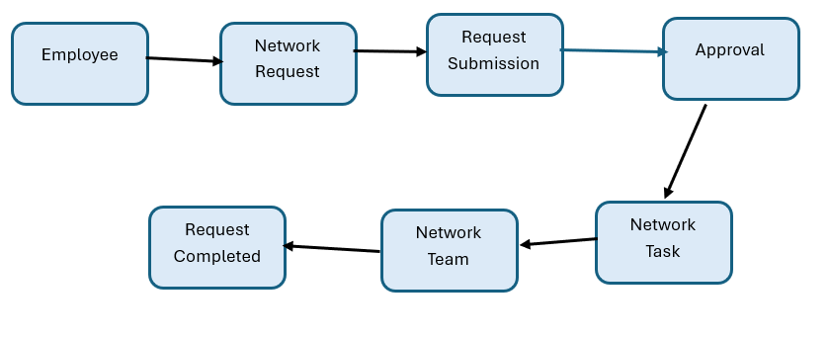
Figure 1: High-level workflow of the Automated Network Request Management System.

1.2 Purpose
The purpose of this project is to provide a centralized and structured process for managing network service requests.
The system aims to:
- Simplify network request submission.
- Capture complete request information.
- Reduce manual processing.
- Automate approvals.
- Automatically create fulfillment tasks.
- Assign tasks to the Network Team.
- Improve request tracking and visibility.

2. IDEATION PHASE
2.1 Problem Statement
Employees may face difficulties when requesting network-related services because requests can be submitted through unclear or unstructured processes. Incomplete information and manual processing can cause delays in approvals and fulfillment.
Problem Statement Canvas
Parameter | Description
User | Employees requesting network services
Problem | Network requests may be unclear or incomplete
Need | A simple and structured request process
Impact | Delays in approval and fulfillment
How Might We? | How might we provide a centralized system for submitting and managing network requests efficiently?

2.2 Empathy Map Canvas
Employee / End User Perspective
Dimension | Employee Perspective
Says | I need a simple way to request network services.
Thinks | I want a clear form with relevant options.
Does | Opens the portal, selects Network Request, and submits details.
Feels | Wants fast and reliable network support.
Pain Points | Incomplete requests, unclear forms, and delayed processing.
Needs / Goals | Simple submission, clear tracking, and timely fulfillment.

2.3 Brainstorming & Idea Prioritization
During the ideation phase, different features were identified to improve the network request process.
Idea | Priority
Network Request Catalog Item | High
Catalog Variables | High
Catalog UI Policies | High
Approval Process | High
Flow Designer Automation | High
Network Task Creation | High
Network Team Assignment | High
Request Status Tracking | Medium
Notifications | Medium
Reports and Dashboards | Medium
The high-priority features were selected for the initial implementation because they directly support the core request and fulfillment workflow.

3. REQUIREMENT ANALYSIS
3.1 Customer Journey Map
The employee journey begins when a user accesses the Service Portal and ends when the network request is fulfilled.
Stage | Employee Action | System Response
Access | Opens Service Portal | Portal displays available services
Discover | Finds Network Request | Catalog item is displayed
Submit | Enters request details | Variables capture information
Validate | Completes required fields | UI Policies validate the form
Process | Submits request | REQ and RITM are created
Approval | Waits for approval | Approval workflow is triggered
Fulfillment | Request is processed | Network Task is created
Completion | Receives completed service | Request status is updated

3.2 Solution Requirements
Functional Requirements
ID | Requirement
FR-01 | Employees shall access the Network Request Catalog Item.
FR-02 | The system shall capture required request information.
FR-03 | The system shall validate mandatory fields.
FR-04 | Relevant fields shall be displayed dynamically.
FR-05 | The system shall create request records after submission.
FR-06 | The request shall be sent for approval.
FR-07 | A Network Task shall be created after approval.
FR-08 | The Network Team shall process the assigned task.

Non-Functional Requirements
ID | Requirement
NFR-01 | The system should provide a simple user interface.
NFR-02 | The system should use ServiceNow access controls.
NFR-03 | The workflow should process requests consistently.
NFR-04 | The system should provide normal ServiceNow response performance.

3.3 Logical Data Flow Diagram
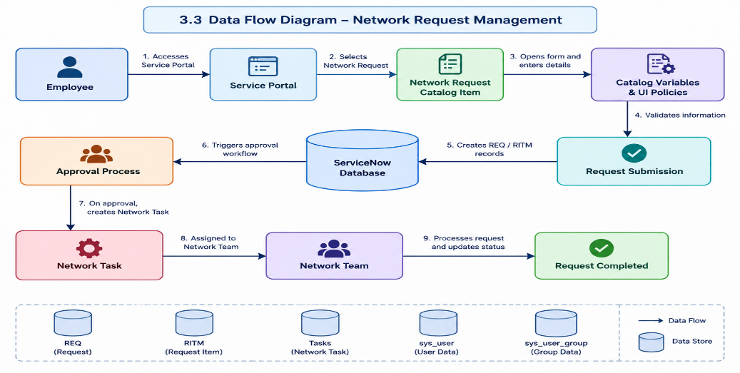

3.4 Technology Stack
S.No. | Component | Description | Technology
1 | User Interface | Employee-facing request interface | Service Portal / Service Catalog
2 | Catalog | Network request submission | Service Catalog
3 | Rules | Dynamic fields and validation | Catalog UI Policies
4 | Automation | Approval and workflow processing | Flow Designer
5 | Data | Request and fulfillment records | REQ / RITM / Tasks
6 | References | User and group information | sys_user / sys_user_group

4. PROJECT DESIGN
4.1 Problem–Solution Fit
Parameter | Project Fit
Problem | Employees need a simple and structured way to submit network requests.
Solution | A ServiceNow-based Network Request Management system.
Customer Benefit | Guided request entry and better request visibility.
Operational Benefit | Structured requests improve approvals and fulfillment.
Uniqueness | Combines Service Catalog, UI Policies, approvals, and task automation.
Scalability | Additional request types and automation can be added later.

4.2 Proposed Solution
The proposed solution is a ServiceNow-based Network Request Management system.
Employees submit network-related requests through a Network Request Catalog Item. Catalog variables capture request information, while Catalog UI Policies provide dynamic form behavior and validation.
After submission, the request is processed through an approval workflow. Once approved, a Network Task is created and assigned to the Network Fulfillment Team.
4.3 Solution Architecture
The solution architecture connects the Service Portal, Network Request Catalog, validation rules, approval process, and Network Tasks.
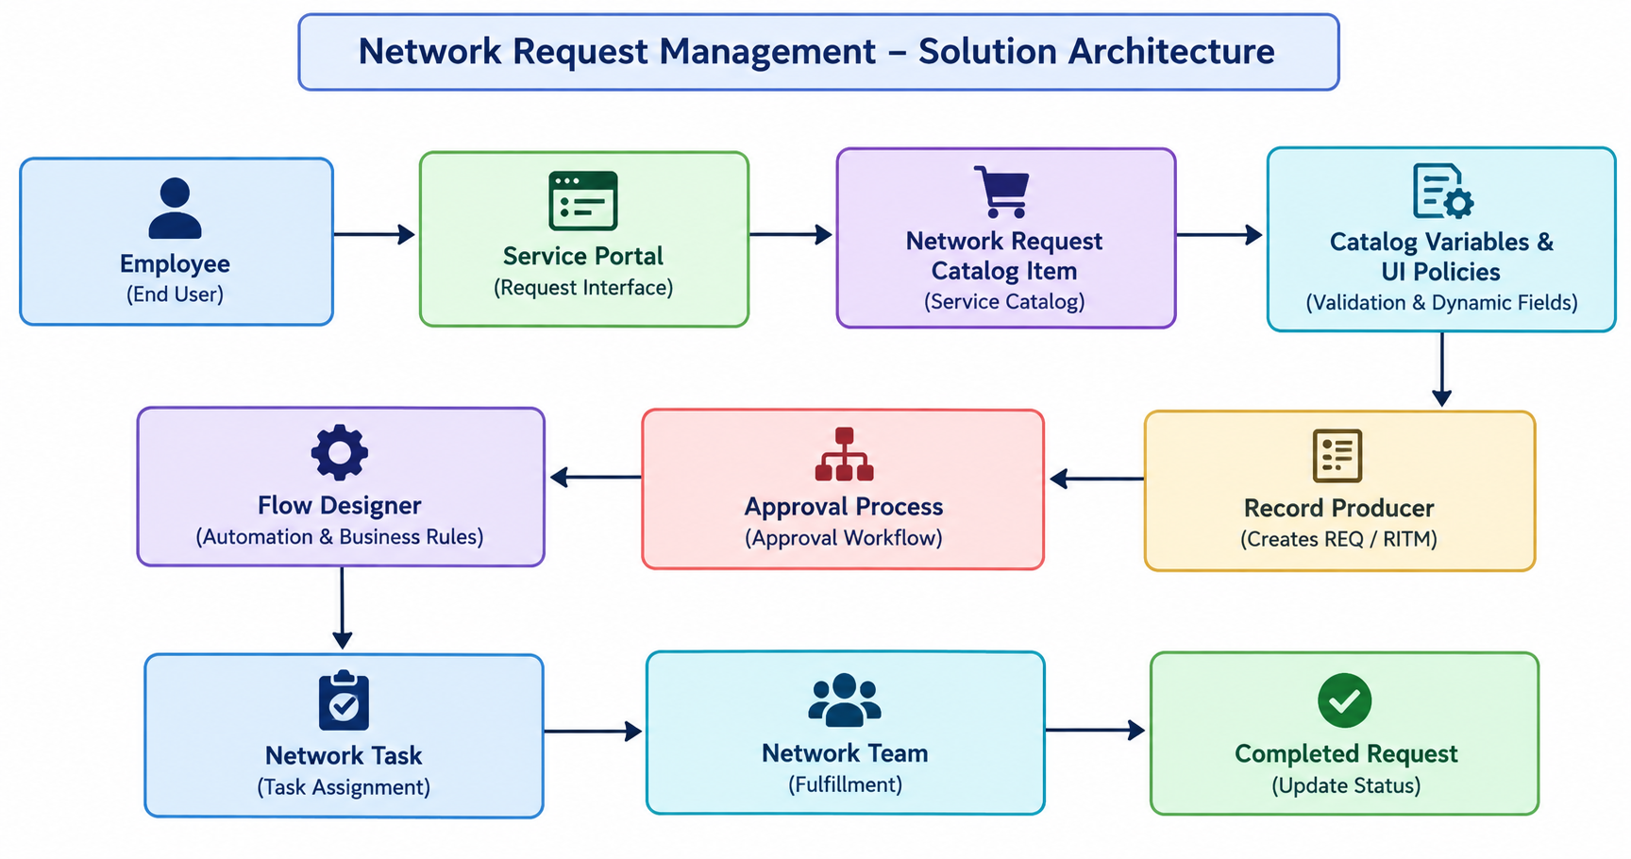

5.

PROJECT PLANNING & SCHEDULING
5.1 Project Planning
The project was divided into four implementation sprints.
Sprint | Functional Requirement | User Story / Task | Story Points | Priority | Student Name
Sprint-1 | Foundation | Create Network Request components and fields | 6 | High | Ambica Tenagala
Sprint-2 | Catalog & Rules | Create catalog item, variables, and UI Policies | 6 | High | Ambica Tenagala
Sprint-3 | Automation | Configure approvals and Network Task creation | 6 | High | Ambica Tenagala
Sprint-4 | Testing | Testing and documentation | 2 | High | Ambica Tenagala

6. FUNCTIONAL AND PERFORMANCE TESTING
6.1 Functional Testing
Test ID | Scenario | Expected Result | Status
TC-01 | Open Service Portal | Portal loads successfully | Pass
TC-02 | Find Network Request | Catalog item is visible | Pass
TC-03 | Open request form | Form opens successfully | Pass
TC-04 | Enter request details | Variables are available | Pass
TC-05 | Select device type | Relevant options display | Pass
TC-06 | Validate fields | Mandatory validation works | Pass
TC-07 | Submit request | REQ and RITM are created | Pass
TC-08 | Approval process | Request goes for approval | Pass
TC-09 | Create Network Task | Task is created | Pass
TC-10 | End-to-end test | Complete workflow works | Pass

6.2 User Acceptance Testing (UAT)
UAT ID | Scenario | Acceptance Criteria | Result
UAT-01 | Open Service Portal | Portal accessible | Accepted
UAT-02 | Find Network Request | Catalog item visible | Accepted
UAT-03 | Open form | Request form opens | Accepted
UAT-04 | Select Device Type | Option selectable | Accepted
UAT-05 | Validate fields | Required validation works | Accepted
UAT-06 | Submit request | Request created | Accepted
UAT-07 | Approval | Approval works | Accepted
UAT-08 | Task creation | Task assigned | Accepted
UAT-09 | Complete request | Request completed | Accepted
UAT Conclusion
The tested Network Request Management workflow satisfies the documented acceptance criteria for the implemented scope.

6.3 Performance Testing
The implemented workflow was tested for normal interactive usage within the ServiceNow Personal Developer Instance.
The application successfully handled:
- Catalog form loading.
- Request submission.
- Validation processing.
- Approval workflow execution.
- Network Task creation.
Note: Large-scale concurrent-user load testing was outside the scope of the project.

7. RESULTS
7.1 Output Screenshots
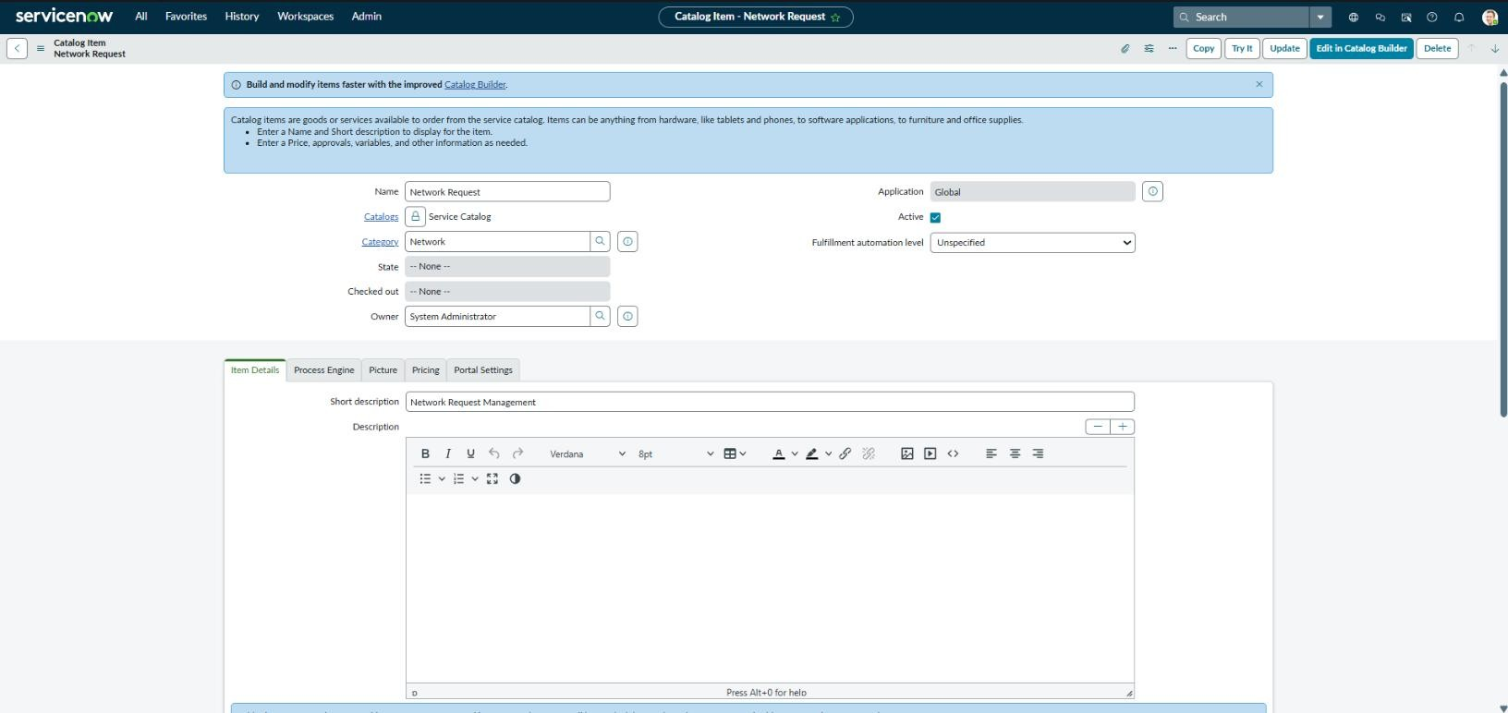
Fig 7.1 Network Request Catalog Item

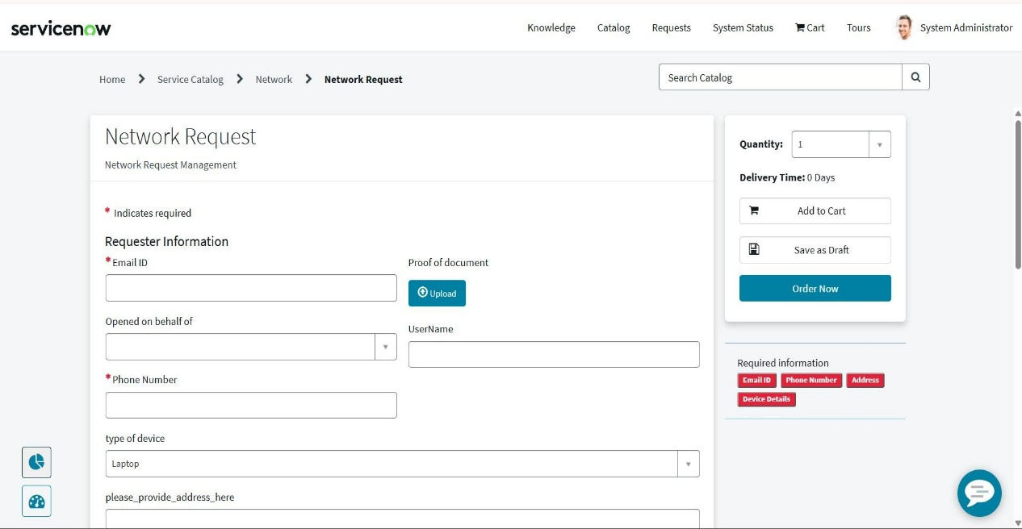

Fig 7.2 Network Request Form

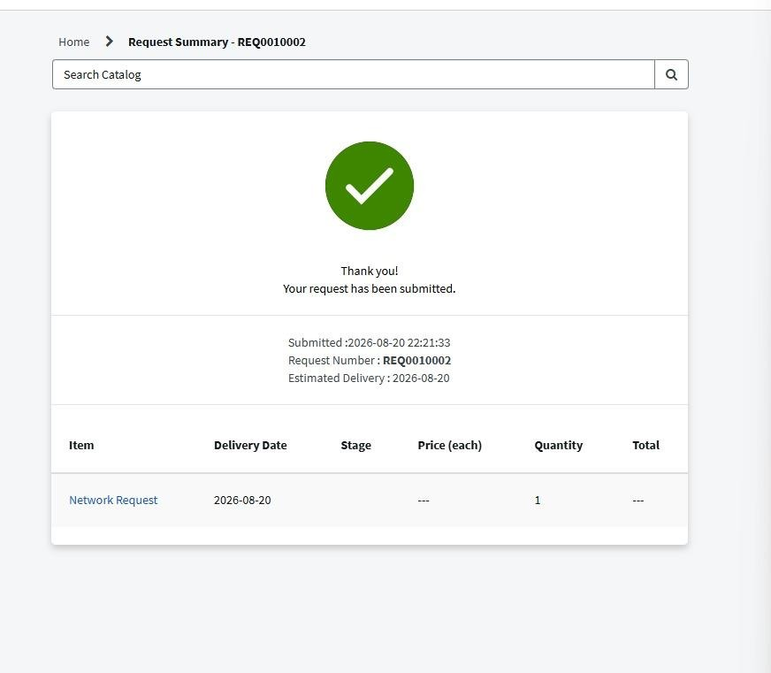

Fig 7.3 Submitted Network Request Record
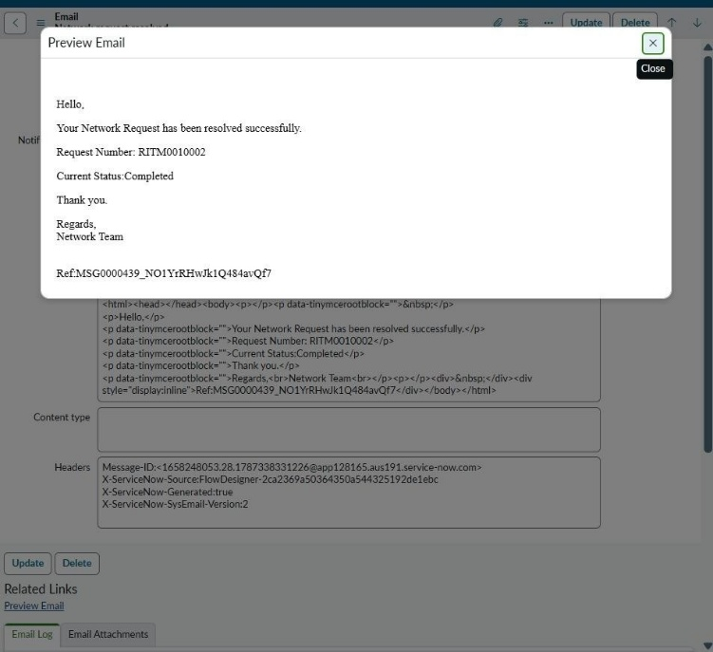

fig 7.4 Email Notification
7.2 Work Item Status Validation
Work Item | Status | Validation
Network Request Catalog | Completed | Catalog item created
Catalog Variables | Completed | Required fields configured
UI Policies | Completed | Dynamic behavior configured
Approval Process | Completed | Approval configured
Flow Designer | Completed | Workflow automation configured
Network Tasks | Completed | Tasks created for fulfillment
Service Portal | Completed | Catalog accessible
Testing | Completed | Workflow validated

8. ADVANTAGES & DISADVANTAGES
Advantages
- Provides centralized network request submission.
- Reduces incomplete request information.
- Improves request standardization.
- Automates approvals and task creation.
- Improves visibility into the request lifecycle.
- Reduces manual effort for the Network Team.
Disadvantages
- Depends on correct ServiceNow configuration.
- Initial configuration requires platform knowledge.
- Complex workflows may require additional maintenance.
- Advanced integrations may require additional development.

9. CONCLUSION
The Automated Network Request & Fulfillment Management System provides a structured approach to managing network service requests using ServiceNow.
The solution enables employees to submit requests through a centralized catalog, captures required information, validates user input, supports approval processing, and automates Network Task creation.
The project demonstrates how ServiceNow capabilities such as the Service Catalog, Catalog UI Policies, Flow Designer, Approvals, and Task Management can be combined to improve operational efficiency and the employee experience.

10. FUTURE SCOPE
The system can be enhanced in the future with:
- Email and mobile notifications.
- Advanced dashboards and reporting.
- SLA monitoring.
- Additional network service categories.
- Automatic priority calculation.
- Integration with external network monitoring tools.
- AI-based request classification.
- Virtual Agent support.
- Knowledge articles for common network issues.

11. APPENDIX
Appendix A – Technology Components
- ServiceNow Service Catalog
- Catalog Items
- Catalog Variables
- Catalog UI Policies
- Flow Designer
- Approval Engine
- REQ and RITM Records
- Network Tasks
- sys_user
- sys_user_group

Appendix B – Project Flow